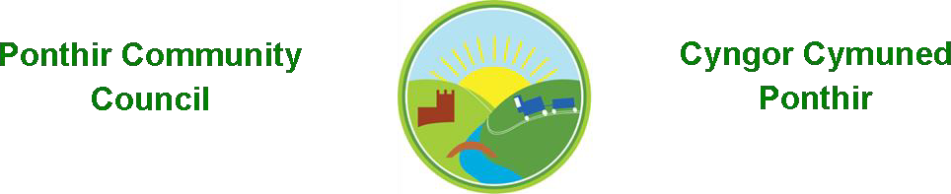
Councillor Expenses 23/24

The following were paid £150 each in respect of expenses for Council duties: -
Cllr I Danaher
Cllr M Leighton
Cllr L Morgan

Councillor Expenses 24/25
The following were paid £150 each in respect of expenses for Council duties: -
Cllr I Danaher
Cllr R Morgan

C Danaher Clerk to the Council.

